Student’s name | …………………………………………………….…… | Grade | 5
Subject | Computer | Quiz No. | 1
Quiz No. ( 1 ) (Answer)

10

write the correct name of each part.


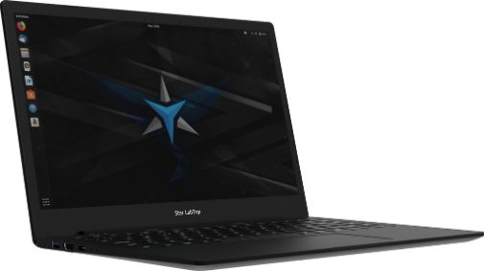
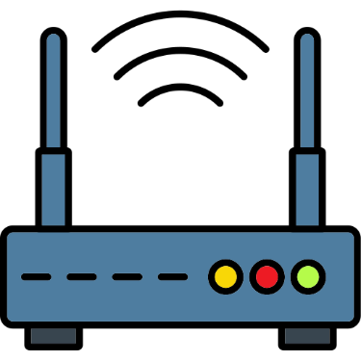

Good Luck

NFC
Router
Bluetooth
Laptop
NFC
Laptop
Router
Bluetooth
Vector

